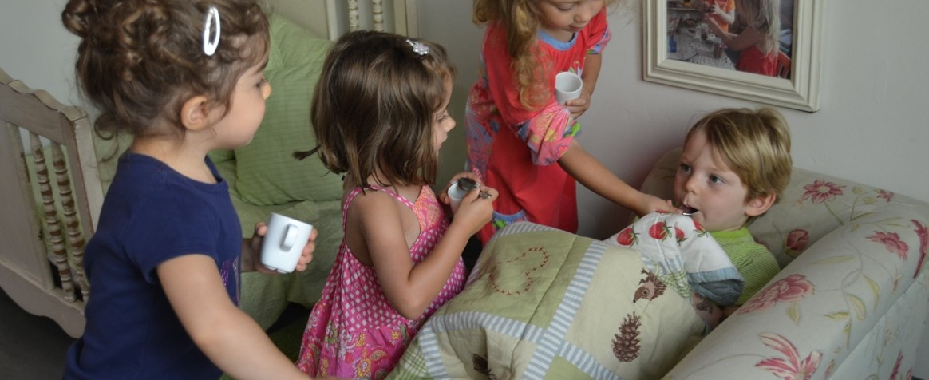
During our appointment in the House Area, Dario pretended to be sick. Fiona, Lela, and Tulip immediately began taking care of him:
Lela: He is sick.
Fiona: Let’s make hot chocolate. That will make him feel good.
Tulip: I’m feeding Dario a little medicine because he doesn’t feel good.
Fiona: Oh, no! Dario is getting off the bed!
Tulip: No, no. You are sick, Dario. Here is the thermometer. Let’s take your temperature.
Fiona, Lela, Tulip: Poor Dario.
Tulip: Tell me when you are better.
Dario: I’m not better yet.
Fiona: Your cold is going to be here for a few days.
Tulip: You gotta get some sleep because if your grandma comes and you are not better she is going to say go back to bed.
Fiona: He really likes medicine.
Tulip, Lela, Fiona: We’re all doctors!
The interactions between these children reflect our research question posted in the House Area:
“What will we discover about ourselves through the roles of play?”
The play invitation Dario offered these girls by pretending to be sick gave them an opportunity to exercise their inner compassion and common concern for the wellbeing of a friend. We were able to observe where this care came from. All the cures: hot chocolate, medicine, rest and caregivers: grandparents, doctors and you. They took their personal experiences and used them to gain perspective, an essential life skill. As Ellen Galinsky states: “Perspective taking involves the intellectual skill of discerning how someone else thinks and feels.” We understand that play is the work and through this play, we learn more about the players and their home cultures. This informs us and them about similarities and differences which bond us in community at New School-West. -Flora & Kris

We Are All Doctors! Tulip, Fiona, Lela.
September 10, 2014

